______________________________________________________________

UM-SJTU JOINT INSTITUTE

INTRO TO CIRCUITS

(VE 215)

______________________________________________________________

LABORATORY REPORT

LAB 4

AC LAB

|  |  |  |
| --- | --- | --- |
| Name: Weikai Zhou | ID: 518021911039 |  |
| Date: 12 November 2019 |  |  |

1. **Introduction [1]**
   1. **Objectives**

* Learn how to define, calculate, and measure the amplitude of a sinusoidal signal.
* Learn how to define, calculate, and measure the Rise Time and Fall Time of a signal.
* Learn how to observe FFT spectra of signal and measure their parameters with cursors.
* Measure the waveforms and FFT spectra of various signals
* Compare the theoretical results obtained in the Pre-Lab with the In-Lab data
  1. **Theoretical background & Apparatus**
     1. **High-Z mode**

Here we are going to learn what the High-Z mode is we have kept emphasizing during the previous labs.

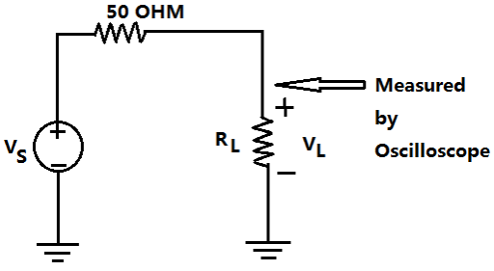We have already learnt Thevenin equivalent of a circuit. We can think the function generator in terms of its Thevenin equivalent circuit, which includes the voltage source and and the equivalent resistance of 50 Ω as shown below (Figure 1).

Figure 1. Thevenin equivalent circuit

When the load is 50 Ω , according to voltage division, we know that the measured will be 0.5 . In this case, we use the 50 OHM mode, in which the function generator produces voltage but displays voltage 0.5 . In that way, if you set 2 for the function generator, the actual will be 4 to make sure the load get a voltage of 2 .

In our lab measurements, the load resistance is very high—the input resistance of the oscilloscope is about 1 MΩ . The measured across practically equals . So, we use High-Z mode, in which the function generator produces voltage and displays .

* + 1. **The rise time and fall time of signals**

The Rise time is the interval between the moment of the time when the signal reaches its 10% level and the moment of time when the signal reaches its 90%. We have already used this concept in our Lab3.

Figure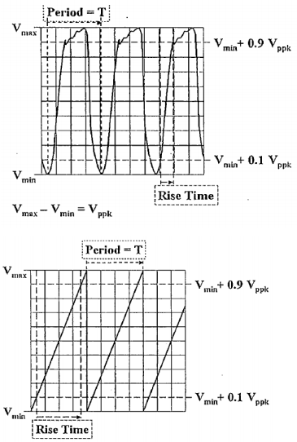 2. The rise time of a sinusoidal like wave and a saw-tooth wave

The above figure illustrates the rise time of a sinusoidal like wave and a saw-tooth wave. If we do not know what is , we can refer to part 4 of this section.

Take the sinusoid wave as an example to calculate the rise time.

* + 1. **Fourier series representation of a signal**

Here we are going to learn a general idea of Fourier Series to help us understand some parts of this lab. we will learn Fourier Series in detail in our math course this semester. Fourier series is a way to represent a wave-like function as a combination of simply sine waves. It decomposed and period function into the sum of a (possibly infinite) set of simple oscillation functions.

Let be a periodic signal with fundamental period . It can be represented by the following synthesis equation,

The coefficients in the above equation can be calculated by the analysis equation,

We can also use the above Mathematic code to get the feeling of how a series of sinusoidal waves can form a square wave (actually, any waveform). We can change the value in the red box, and the larger the value is, the more accurate the result will be. Here we thank the Vv286 TA for FA2014 Gao Yuan for offering us the source code.

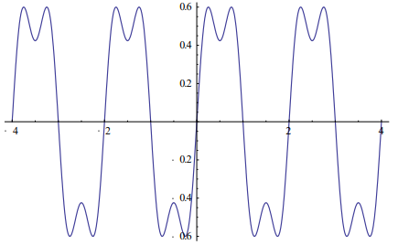For value 3, we can get the following result

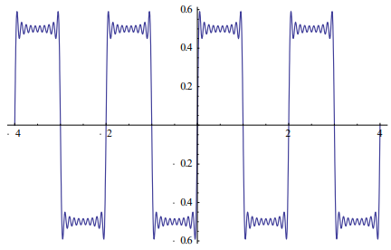 For value 20, we can get the following result,

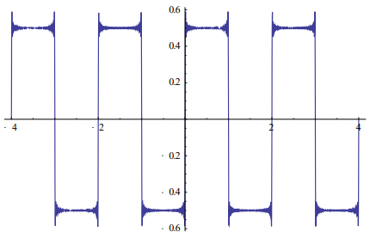 And for value 100, we get,

* + 1. 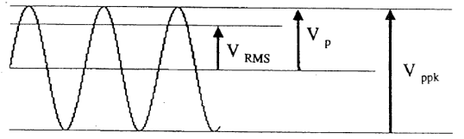**Four ways to measure the amplitude of a sinusoid**

1. is the peak amplitude of the sinusoid measured in V or mV.
2. is the value we often use in the lab to determine the overall size of the waveform. We have used it many times in the previous Labs.
3. is the Root-Mean-Square, or RMS amplitude of the sinusoid. The sinusoidal voltage dissipates as much power in the load resistor as does the DC voltage equals to

For any periodic function that has period *T*, the RMS amplitude is defined as

In the case of sinusoid ,

1. The above three ways all study the signal in time domain, plotted as voltage vs. time. In this Lab, we also need to study the frequency domain, when we measure their spectra displayed as amplitude vs. frequency. In frequency domain, the oscilloscope measures the amplitude of on a logarithmic scale, using **decibels**.

Decibels are used to calculate ratios of **two** amplitudes on a logarithmic scale.

* + 1. **Apparatus**

The experimental setup of this experiment consists of function generator, oscilloscope and so on.

1. **Measurements [1]**

**Part I**

1. On the function generator, we should set a sine wave at 1 [kHz] and keep its amplitude at 3 []. The load must be High-Z mode.
2. We should record the parameters on the datasheet. We should fill the table with the data set on the function generator and displayed on the oscilloscope.
3. We should repeat the Step b) with a sine wave at 1.5 [kHz] and 5 [] on the function generator. The load should remain High-Z mode.
4. In post-report, we should calculate the rise time in theory and compare it with the values displayed on the oscilloscope.
5. We should reminder:

**Part II**

1. First, we set a sine wave and a square wave, respectively. The frequency is 1 [kHz] and the amplitude is 3 [].
2. On the oscilloscope, we should set 1 [V/div] and 5 [ms/div].
3. We should push the “MATH” button and select “FFT” function.
4. We should push the “cursor” button and select “trace” mode to trace the spectrum.
5. When the cursor reaches a peak of the spectrum, we should record the Frequency in [kHz] and the Amplitude in [dBV].
6. We should set another sine wave and a square wave. The frequency is 2 [kHz] and the amplitude is 6 []. We should repeat the steps above.
7. In post-report, we need to calculate the theoretical amplitude of sine wave in [dBV]. Besides, we need to calculate the of each square wave measured in Part II. We should give a brief conclusion on what we learn from this lab.
8. We should reminder:

For sine wave,

For square wave,

1. **Results & discussion** **[2]**
   1. **Part I**

As described in procedure part, we can get the table below (Table 1).

|  |  |  |
| --- | --- | --- |
|  | Set on function generator | Measured with oscilloscope |
| Amplitude in | 3.000 | 3.06 |
| Frequency [kHz] | 1.000 | 1.01 |
| Rise time [ | 295.17 | 280 |
| Amplitude in | 5.000 | 5.12 |
| Frequency [kHz] | 1.500 | 1.51 |
| Rise time [ | 196.78 | 198 |

Table 1. Rise time measurement

For the sine wave with 1 [kHz] and amplitude 3 [], we can calculate the theoretical rise time as:

The value displayed in the oscilloscope is 280, so we can calculate the relative error as

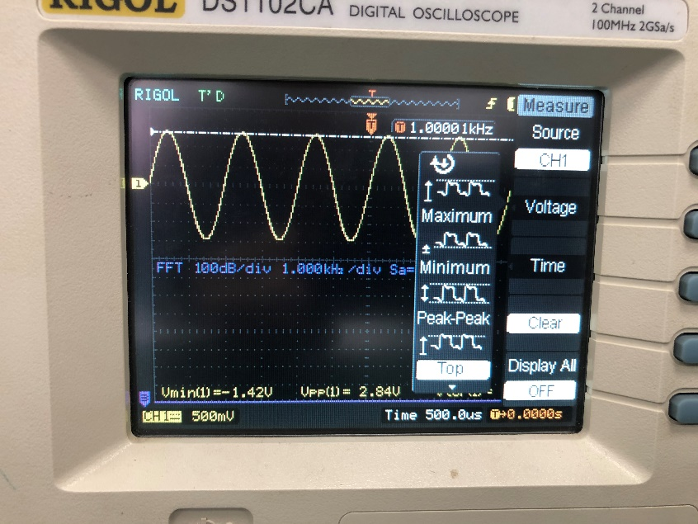This is the figure for it:

For the sine wave with 1.5 [kHz] and amplitude 5 [], we can calculate the theoretical rise time as:

The value displayed in the oscilloscope is 198, so we can calculate the relative error as

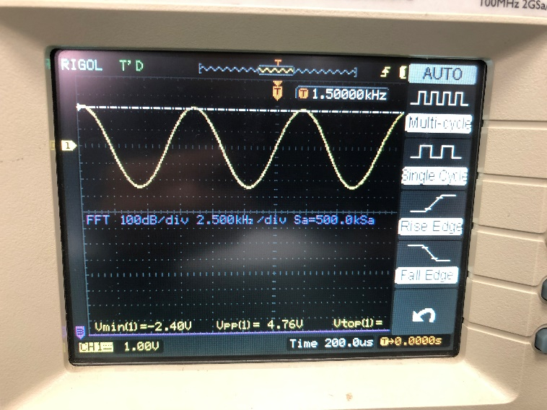This is the figure for it:

We can find that the relative error decreases when the frequency and amplitude increase. This may be because that when the frequency and amplitude increase, it is easier for oscilloscope to measure the value precisely. And the reasons for the error may be the bad contact of circuits, the resistance of the wire and so on.

* 1. **Part II**
     1. **The wave at 3 [] 1 [kHz]**

As described in procedure part, we can get the table below (Table 2 & 3).

|  |  |  |
| --- | --- | --- |
| Peak | Frequency (measured) [kHz] | Amplitude (measured) [dBV] |
|  | 1.000 | -0.300 |

Table 2. FFT spectrum for sine wave

|  |  |  |
| --- | --- | --- |
| Peak | Frequency (measured) [kHz] | Amplitude (measured) [dBV] |
|  | 1.000 | 1.545 |
| 3 | 3.000 | -7.800 |
| 5 | 5.000 | -12.380 |
| 7 | 7.000 | -15.237 |
| 9 | 9.000 | -17.408 |

Table 3. FFT spectrum for square wave

For the sine wave, we can calculate the theoretical amplitude as

with relative error

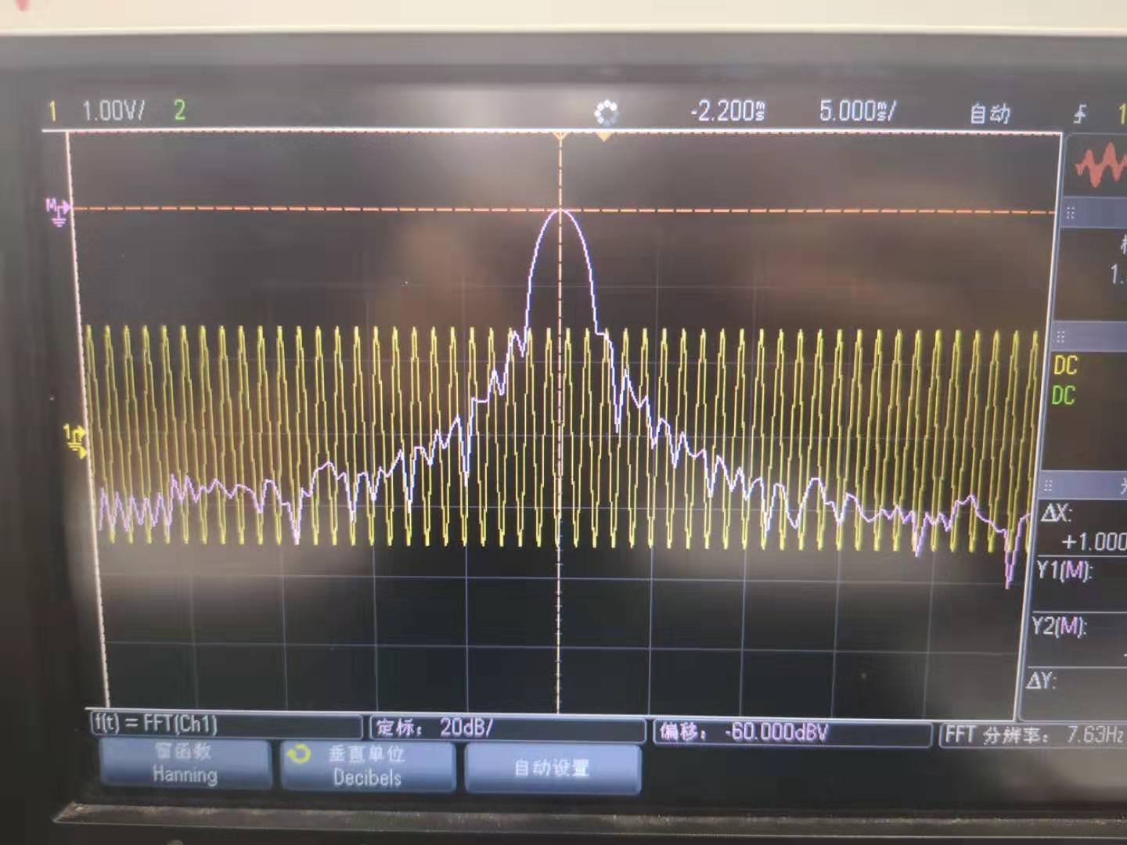And the figure for it is

For the square wave, we can calculate the respectively:

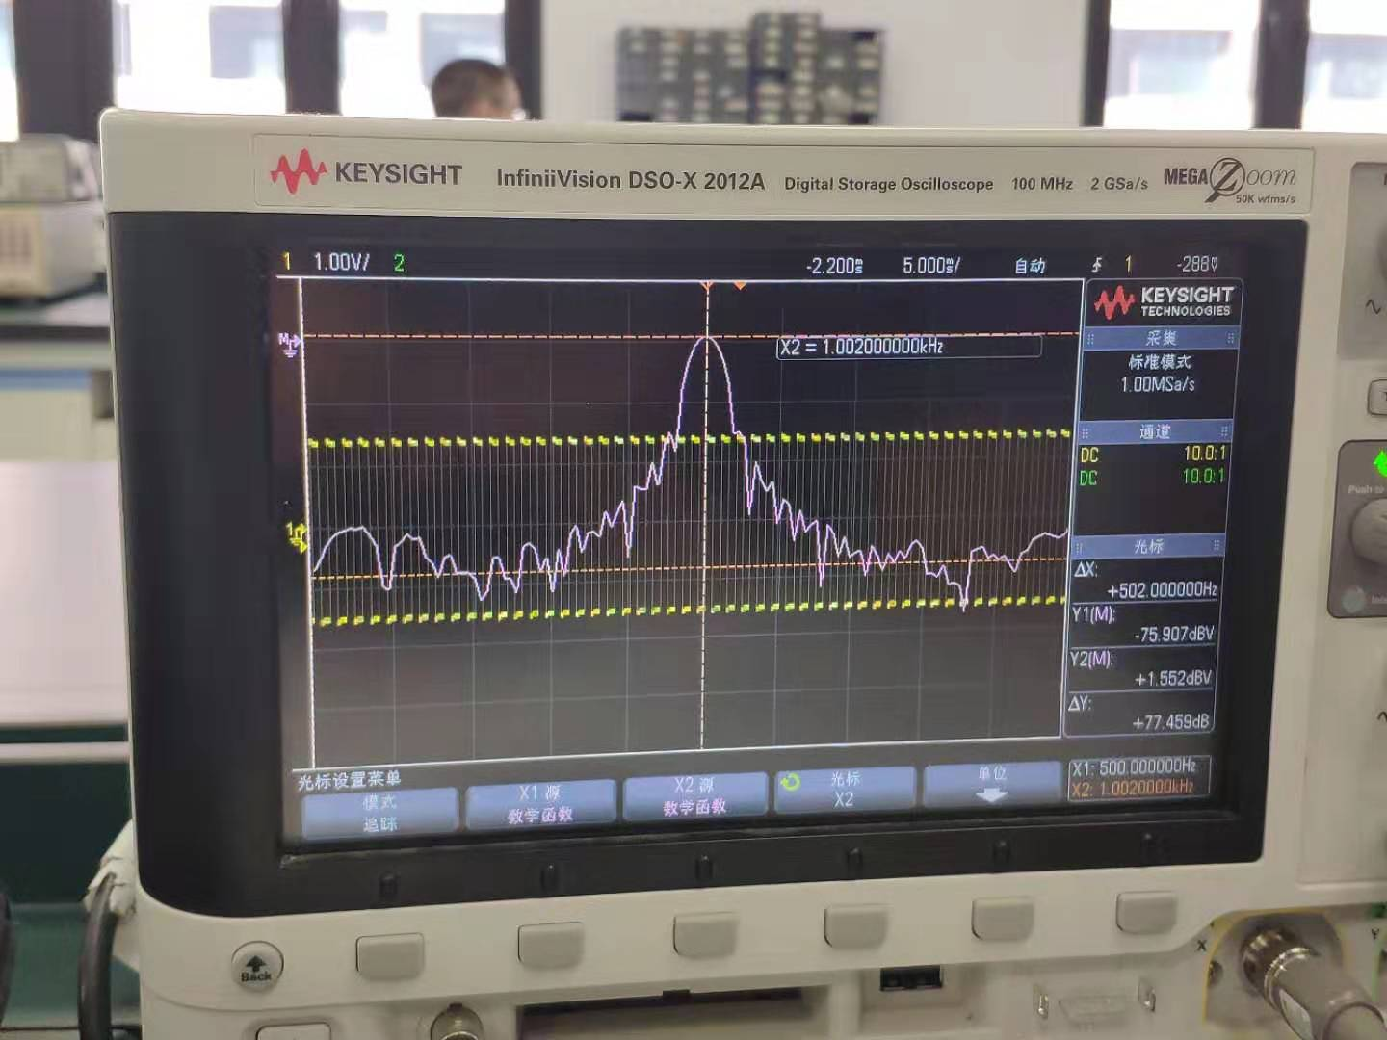And the figure for it is

* + 1. **The wave at 6 [] 2 [kHz]**

As described in procedure part, we can get the table below (Table 4 & 5).

|  |  |  |
| --- | --- | --- |
| Peak | Frequency (measured) [kHz] | Amplitude (measured) [dBV] |
|  | 2.000 | 5.716 |

Table 4. FFT spectrum for sine wave

|  |  |  |
| --- | --- | --- |
| Peak | Frequency (measured) [kHz] | Amplitude (measured) [dBV] |
|  | 2.000 | 7.714 |
| 3 | 6.000 | -1.814 |
| 5 | 10.000 | -6.230 |
| 7 | 14.000 | -9.041 |
| 9 | 18.000 | -11.314 |

Table 5. FFT spectrum for square wave

For the sine wave, we can calculate the theoretical amplitude as

with relative error

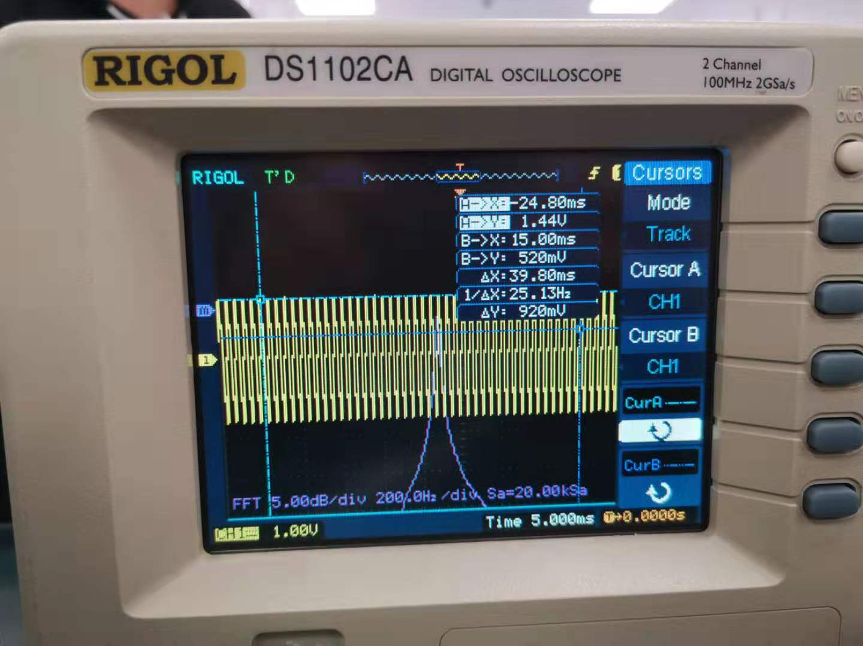And the figure for it is

For the square wave, we can calculate the respectively:

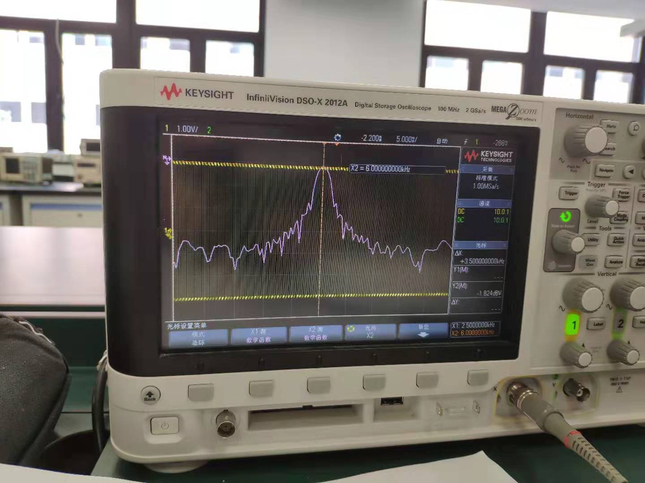And the figure for it is

1. **Conclusions [1]**

In this experiment, we learn how to define, calculate, and measure the amplitude of a sinusoidal signal; learn how to define, calculate, and measure the Rise Time and Fall Time of a signal; learn how to observe FFT spectra of signal and measure their parameters with cursors; measure the waveforms and FFT spectra of various signals; compare the theoretical results obtained in the Pre-Lab with the In-Lab data.

Also, we have basic understanding of the High-Z mode, the rise time and fall time of signals, Fourier Series representation of a signal, and four ways to measure the amplitude of sinusoid.

For Part I, we measure the amplitude, frequency and rise time of the signal. We compare the measured value with the theoretical value and find that the relative decreases when the frequency and amplitude increase. This may be because that when the frequency and amplitude increase, it is easier for oscilloscope to measure the value precisely.

For Part II, we measure the frequency and amplitude of the signal. Then, we calculate the theoretical amplitude of sine wave in [dBV] and the of each square.

1. **References**

[1] Lab4_AC Lab_Manual

[2] Lab4_AC Lab_DataSheet